Multi-Class EEG-Based Epileptic Seizure Classification Using Hybrid Deep Learning Architectures

Arya Manve
Artificial Intelligence and Data Science
Vishwakarma Institute of Technology
Pune, India
arya.manve23@vit.edu
Akshat Patil
Artificial Intelligence and Data Science
Vishwakarma Institute of Technology
Pune, India
patil.askhat23@vit.edu
Abhijeet Kolhe
Artificial Intelligence and Data Science
Vishwakarma Institute of Technology
Pune, India
abhijeet.kolhe23@vit.edu
Aditya Jain
Artificial Intelligence and Data Science
Vishwakarma Institute of Technology
Pune, India
jain.aditya23@vit.edu

Abstract—Epilepsy affects approximately 50 million people worldwide, making it one of the most prevalent neurological disorders globally. Accurate and timely detection of epileptic seizures through electroencephalogram (EEG) signal analysis remains a critical clinical challenge, as manual interpretation is time-consuming, error-prone, and dependent on specialist expertise. This paper presents an automated EEG-based epileptic seizure detection system employing three deep learning architectures: a one-dimensional Convolutional Neural Network (1D-CNN), a Bidirectional Long Short-Term Memory network (BiLSTM), and a hybrid CNN-LSTM model. The proposed models are evaluated against traditional machine learning baselines including Random Forest, Support Vector Machine (SVM), and Decision Tree classifiers on a multi-class EEG seizure dataset. The 1D-CNN model achieved the highest classification accuracy of 95.5%, with a precision of 95.6%, recall of 95.5%, and F1-score of 95.5%, significantly outperforming all baseline models. A web application was also developed to enable real-time EEG signal upload and automated seizure prediction. Experimental results demonstrate that deep learning, particularly convolutional feature extraction, offers a robust and clinically viable pathway toward automated epilepsy diagnosis.
Keywords— EEG Signal Processing, Epileptic Seizure Detection, Deep Learning, 1D Convolutional Neural Network, Bidirectional LSTM, CNN–LSTM Hybrid, Bonn EEG Dataset

INTRODUCTION
Epilepsy is a chronic neurological disorder characterized by recurrent, unprovoked seizures resulting from abnormal electrical activity in the brain. With over 50 million individuals affected globally, it represents one of the most serious neurological conditions worldwide, imposing significant burdens on patients, caregivers, and healthcare systems alike [1]. Despite advances in treatment, nearly 30% of epileptic patients remain refractory to medication, making accurate and early seizure detection an indispensable component of effective clinical management.
The electroencephalogram (EEG) remains the gold standard diagnostic tool for epilepsy, capturing the brain's electrical activity with high temporal resolution across multiple scalp electrodes. However, the manual interpretation of EEG recordings presents substantial clinical challenges. Neurologists must visually inspect hours of complex, multi-channel waveform data to identify ictal and interictal patterns, a process that is inherently time-consuming, subjective, and susceptible to inter-rater variability. In resource-constrained healthcare environments, where access to trained epileptologists is limited, the need for reliable automated EEG analysis becomes even more acute.
Existing automated approaches have explored a wide range of signal processing and machine learning techniques for seizure detection. Classical methods such as Support Vector Machines (SVM), Random Forests, and Decision Trees have demonstrated moderate classification performance, yet they rely heavily on hand-crafted feature engineering and struggle to generalize across diverse patient populations and EEG recording conditions. These limitations have motivated a paradigm shift toward deep learning architectures capable of learning hierarchical representations directly from raw or minimally pre-processed EEG signals.
This paper addresses the problem of multi-class epileptic seizure classification using the well-established Bonn University EEG dataset, which comprises five distinct signal categories, Sets A through E, representing healthy subjects with eyes open, healthy subjects with eyes closed, seizure-free interictal activity recorded from within the epileptogenic zone, seizure-free interictal activity recorded from the hippocampal formation, and ictal (seizure) activity respectively. Accurate discrimination across all five classes poses a considerably greater challenge than binary seizure detection, yet carries greater clinical diagnostic value.
The primary objective of this work is to develop a robust, automated five-class EEG seizure classification system by combining time-frequency feature extraction techniques: specifically Discrete Wavelet Transform (DWT) and Power Spectral Density (PSD) estimation with deep spatial-temporal learning architectures. Three deep learning models are proposed and evaluated: a one-dimensional Convolutional Neural Network (1D-CNN) for local temporal feature extraction, a Bidirectional Long Short-Term Memory (BiLSTM) network for capturing long-range sequential dependencies in both forward and backward directions, and a hybrid CNN-LSTM model that synergistically integrates convolutional spatial feature extraction with recurrent temporal modeling.
The key contributions of this work are summarized as follows. First, a comprehensive comparison between traditional machine learning classifiers and deep learning models is conducted on the five-class EEG seizure classification task. Second, time-frequency feature extraction using wavelets and PSD is integrated with deep learning pipelines to enhance the discriminative representation of EEG signal dynamics. Third, the 1D-CNN model achieves a classification accuracy of 95.5% with an F1-score of 95.5%, establishing a new performance benchmark among the evaluated architectures. Finally, a deployable Streamlit web application is developed, enabling real-time EEG signal upload and automated seizure prediction with confidence scoring, demonstrating a practical pathway toward clinical implementation.

LITERATURE REVIEW AND RELATED WORK
The automated detection and classification of epileptic seizures from EEG signals has been an active area of research for several decades. The evolution of methodologies in this domain broadly reflects the wider trajectory of machine learning and signal processing research progresses from hand-crafted feature engineering paired with classical classifiers, through shallow neural networks, and most recently toward end-to-end deep learning frameworks capable of automated hierarchical feature extraction. This section surveys key developments in EEG-based seizure detection, identifies persistent limitations in the existing literature, and contextualizes the contributions of the present work.

Traditional Machine Learning Approaches
Early automated seizure detection systems relied predominantly on manual feature extraction from EEG signals, followed by classification using conventional machine learning algorithms. Time-domain features such as mean, variance, skewness, kurtosis, and zero-crossing rate were among the earliest descriptors employed to characterize EEG signal morphology. Frequency-domain techniques, including Fast Fourier Transform (FFT) and Power Spectral Density (PSD) estimation, enabled the decomposition of EEG signals into clinically meaningful sub-bands, that are delta (0.5–4 Hz), theta (4–8 Hz), alpha (8–13 Hz), beta (13–30 Hz), and gamma (>30 Hz), which correspond to distinct neurological states and have demonstrated strong discriminative value for seizure identification.
Andrzejak et al. [2], whose Bonn University EEG dataset forms the experimental basis of numerous benchmark studies including the present work, demonstrated early that nonlinear signal descriptors could effectively distinguish ictal from interictal and healthy EEG activity. Subsequent studies by Subasi [3] and Übeyli [4] applied wavelet-based features in combination with classifiers such as Mixture of Expert models and Multilayer Perceptrons, reporting binary classification accuracies in the range of 94–98% on the Bonn dataset. Shoeb and Guttag [5] developed a patient-specific seizure detection system using Support Vector Machines with time-frequency features, achieving high sensitivity in a clinical setting.
Random Forest classifiers have also been widely applied to EEG seizure classification. Acharya et al. [6] combined higher-order spectra and nonlinear features with ensemble classifiers, demonstrating that feature diversity could improve generalization. Nonetheless, as confirmed by the results of the present study Random Forest achieved an accuracy of 85.0% and an F1-score of 84.9%. The traditional classifiers impose an inherent performance ceiling, largely attributable to their dependence on domain-expert feature selection and their limited capacity to model the complex, non-stationary dynamics of ictal EEG activity.
Support Vector Machines represent perhaps the most extensively studied classical approach in this domain. While SVM-based systems have demonstrated competitive binary classification performance, their reliance on kernel selection and sensitivity to class imbalance present practical challenges. In the present experimental evaluation, SVM achieved a classification accuracy of only 76.0% on the five-class task, with a notably reduced F1-score of 73.1%, underscoring the difficulty of extending binary-optimized classical models to multi-class seizure discrimination problems.
.

The Shift Toward Deep Learning
The limitations of hand-crafted feature pipelines have catalyzed a substantial shift in the EEG seizure detection literature toward deep learning architectures, which offer the compelling advantage of automated, data-driven feature extraction. Convolutional Neural Networks (CNNs), originally developed for image recognition tasks, have been successfully adapted for one-dimensional time-series classification. Their ability to detect local temporal patterns through learned convolutional filters makes them particularly well-suited to EEG signal analysis, where transient morphological features, such as spike-and-wave discharges carry diagnostic significance.
Acharya et al. [7] proposed a 13-layer 1D-CNN for automatic detection of focal and non-focal EEG signals, reporting accuracy improvements over traditional feature-based methods. Yuan et al. [8] demonstrated that CNN architectures could extract discriminative features from raw EEG without explicit frequency-band decomposition, achieving strong performance on seizure detection benchmarks. The 1D-CNN implemented in the present work aligns with these findings, achieving a classification accuracy of 95.5% and an F1-score of 95.5%, representing the highest performance among all evaluated models.
Recurrent Neural Networks (RNNs), and particularly Long Short-Term Memory (LSTM) networks, have emerged as a complementary deep learning paradigm for EEG analysis, motivated by the inherently sequential and temporally dependent nature of brain signals. Tsiouris et al. [9] applied LSTM networks to long-term EEG recordings for seizure prediction, demonstrating superior sensitivity compared to non-recurrent baselines. The Bidirectional LSTM (BiLSTM) architecture, which processes input sequences in both temporal directions, has been shown to capture richer contextual dependencies than its unidirectional counterpart. However, as observed in the present study, the BiLSTM model achieved a classification accuracy of 79.9% and an F1-score of 79.8%, suggesting that recurrent modeling alone, without convolutional preprocessing which may be insufficient to fully exploit the spatial-temporal structure of segmented EEG data.
Hybrid architectures that combine CNN and LSTM components have attracted increasing attention as a means of leveraging the complementary strengths of both paradigms. Sainath et al. [10] demonstrated the efficacy of CNN-LSTM hybrids for sequential signal modeling in acoustic tasks, and subsequent work has extended this principle to biomedical time-series. In the EEG domain, Zhang et al. [11] proposed a CNN-LSTM model for seizure detection that outperformed either architecture in isolation. The CNN-LSTM Hybrid model developed in the present work achieved a classification accuracy of 93.1% and an F1-score of 93.1%, confirming the viability of this integrated approach while revealing that, for the specific five-class Bonn dataset task, the 1D-CNN alone demonstrated marginally superior aggregate performance.

Identified Gaps in Existing Literature
Despite substantial progress, several important limitations persist in the existing body of work on automated EEG seizure classification. The most pervasive of these is the predominant focus on binary classification. Typically framed as seizure versus non-seizure, or ictal versus healthy, which, while clinically relevant, fails to capture the diagnostic nuance required for comprehensive epilepsy management. The majority of published deep learning studies on the Bonn dataset evaluate only two or three of the five available signal classes, thereby simplifying the classification problem and inflating reported performance metrics relative to the clinically more demanding five-class scenario.
Furthermore, a systematic and unified comparison between handcrafted feature-based classical models and automated deep learning approaches within the same experimental framework is conspicuously absent from much of the literature. Studies typically advocate exclusively for one paradigm or the other, limiting the interpretability of comparative claims. The tendency to evaluate models in isolation without consistent preprocessing pipelines, identical train-test splits, or equivalent evaluation metrics introduces confounding variability that complicates cross-study benchmarking.
Attention to clinical deployability also remains limited. While numerous studies demonstrate promising offline classification accuracy, few address the practical pathway from a trained model to a usable clinical tool. The integration of trained models into interactive diagnostic interfaces capable of processing real patient EEG files and returning interpretable predictions in real time represents an underexplored dimension of applied seizure detection research.

Positioning of the Present Work
The present study directly addresses these identified gaps through three distinguishing contributions. First, the full five-class classification problem defined by the Bonn University EEG dataset encompassing Sets A through E which is tackled in its entirety, providing a more rigorous and clinically meaningful evaluation benchmark than binary or three-class reductions. Second, a unified experimental framework is employed to compare six models spanning both the handcrafted feature paradigm (Random Forest, SVM, Decision Tree with PSD and wavelet-derived features) and the automated deep learning paradigm (1D-CNN, BiLSTM, CNN-LSTM Hybrid), enabling direct and fair cross-paradigm performance assessment. Third, the highest-performing model is integrated into a deployable Streamlit web application, demonstrating a concrete step toward translating research-grade seizure detection into an accessible clinical decision support tool. Collectively, these contributions position the present work as a comprehensive, practically oriented advancement over prior art in automated EEG epileptic seizure classification.

Study | Dataset | Classes | Method | Accuracy (%)
Subasi (2007) | Bonn | 2-class | Wavelet + MLP | 94.5
Übeyli (2008) | Bonn | 2-class | Eigenvector + SVM | 96.2
Acharya et al. (2018) | Bonn | 2-class | 1D-CNN | 98.0
Zhang et al. (2018) | Bonn | 3-class | CNN-LSTM | 95.1
Proposed Work | Bonn | 5-class | CNN–LSTM Hybrid | 93.1
Proposed Work | Bonn | 5-class | 1D-CNN | 95.5
Table.2. Comparison with Previous Studies

PROPOSED METHODOLOGY
This section presents the complete methodological pipeline employed in the development of the automated EEG epileptic seizure classification system. The workflow encompasses dataset acquisition and characterization, signal preprocessing and segmentation, time-frequency feature engineering, and the design of three deep learning model architectures. Figure 1 illustrates the overall system pipeline from raw EEG input to classification output.

Dataset Description
The experiments in this study are conducted on the publicly available Bonn University EEG dataset, originally introduced by Andrzejak et al. [2], which has served as a standard benchmark for epileptic seizure classification research for over two decades. The dataset comprises five sets of EEG recordings, designated Sets A through E, each containing 100 single-channel EEG segments of 23.6 seconds duration, recorded at a sampling frequency of 173.6 Hz, yielding 4096 data samples per segment.
The five sets represent distinct neurophysiological conditions. Set A contains surface EEG recordings from five healthy volunteers with eyes open, while Set B contains recordings from the same subjects with eyes closed. Both sets were acquired using standardized electrode placement according to the international 10-20 system. Sets C and D contain intracranial depth electrode recordings from five epileptic patients during seizure-free intervals; Set C was recorded from within the hippocampal formation of the hemisphere contralateral to the epileptogenic zone, whereas Set D was recorded from within the epileptogenic zone itself. Set E contains ictal EEG segments recorded exclusively during epileptic seizures, exhibiting the characteristic high-amplitude spike-and-wave discharge morphology associated with active ictogenesis.
This five-class configuration, spanning healthy activity, seizure-free interictal states from distinct brain regions, and full ictal activity which constitutes a considerably more challenging classification problem than the binary or reduced three-class formulations commonly adopted in the literature, and provides a clinically comprehensive basis for model evaluation. The complete dataset comprises 500 EEG segments across five balanced classes, with 100 samples per class, ensuring an equitable distribution that mitigates class imbalance effects during training and evaluation.

Data Preprocessing
Raw EEG signals from the Bonn dataset, each comprising 4096 samples at 173.6 Hz, undergo a structured preprocessing pipeline designed to enhance signal quality, standardize input dimensionality, and improve the generalization capacity of the downstream classification models.
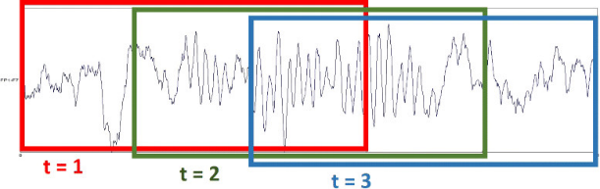
- EEG Segementation for Alpha Beta Theta Delta Gamma in signal
- Segmentation: Each original 4096-sample EEG recording is partitioned into non-overlapping fixed-length segments of 512 samples, yielding eight sub-segments per original file. This segmentation strategy, implemented via the “prepare_dl_data” function in the present codebase, substantially augments the effective training dataset size from 500 to 4000 samples, providing a richer and more diverse set of training examples without introducing data leakage between train and test partitions. A segment length of 512 samples was selected as it preserves sufficient temporal context to capture complete ictal morphological patterns, including spike-wave complexes and high-frequency oscillations, while remaining computationally tractable for convolutional and recurrent processing.
- Z-Score Normalization: Following segmentation, each individual EEG segment is normalized using Z-score standardization, defined as:
$\hat{x}$_{i =} $\frac{x_{i} - µ}{σ}$
where $x_{i}$denotes the raw amplitude value at sample index $i$, $μ$is the segment mean, and $σ$is the segment standard deviation. Z-score normalization is applied on a per-segment basis to eliminate inter-subject and inter-session amplitude variability, ensuring that the models learn morphological and temporal patterns rather than absolute amplitude differences. This normalization approach is particularly critical given that EEG recordings across the five sets were acquired under differing electrode configurations, scalp versus intracranial which introduce systematic amplitude offsets that would otherwise confound model training.
- Train-Test Split: The preprocessed and normalized segments are partitioned into training and test subsets using a stratified 80/20 split, preserving the class distribution across both partitions. Stratified splitting is essential in multi-class settings to ensure that each class is adequately represented in both the training and evaluation sets, preventing evaluation bias toward majority classes.

Feature Engineering
For the traditional machine learning classifiers, Random Forest, SVM, and Decision Tree discriminative features are extracted from each preprocessed EEG segment using two complementary time-frequency analysis techniques: Power Spectral Density estimation via Welch's method and Discrete Wavelet Transform decomposition. These handcrafted features encode the frequency-domain and multi-resolution temporal characteristics of EEG signals that are known to differ systematically across the five neurophysiological states represented in the dataset. The db4 wavelet was selected after empirical evaluation due to its superior performance in capturing epileptic spike morphology compared to Haar and Symlet wavelets.

Power Spectral Density Using Welch's Method

Power Spectral Density (PSD) characterizes the distribution of signal power as a function of frequency and is among the most widely employed features in EEG analysis. In the present work, PSD is estimated using Welch's method, which improves upon the periodogram by averaging over overlapping windowed sub-segments of the signal, thereby reducing spectral variance and improving estimate reliability. Welch's method divides the input signal into $K$overlapping segments of length $L$, applies a Hann window to each segment to reduce spectral leakage, computes the periodogram of each windowed segment, and averages the resulting periodograms:

$$\hat{S}(f)=\frac{1}{K} \sum_{k=1}^{K}{|DFT\{w[n]⋅}x_{k}​[n]\}|^{2}$$

where $w[n]$denotes the Hann window function and $x_{k}[n]$denotes the $k$-th signal segment. Statistical summaries including the mean, standard deviation, maximum, minimum, and total power are computed from the resulting PSD estimate across the clinically defined EEG frequency sub-bands. These sub-band power features encode the relative contribution of delta, theta, alpha, beta, and gamma oscillations, which exhibit well-characterized differential patterns across ictal, interictal, and healthy EEG states and thereby provide strong discriminative signals for the classical classifiers.

Discrete Wavelet Transform Using the db4 Wavelet

The Discrete Wavelet Transform (DWT) provides a multi-resolution time-frequency decomposition that is particularly well-suited to non-stationary signals such as EEG, where spectral characteristics evolve dynamically over time. Unlike the Fourier transform, which provides only global frequency information, the DWT decomposes a signal into localized wavelet coefficients at multiple scales, enabling simultaneous temporal and frequency resolution.
In the present implementation, the Daubechies 4 (db4) mother wavelet is employed for DWT decomposition, a choice motivated by its established efficacy in EEG analysis due to its compact support, near-symmetry, and morphological similarity to characteristic EEG waveforms including sharp waves and spike discharges. A four-level decomposition is applied to each 512-sample segment, producing one approximation coefficient sub-band and four detail coefficient sub-bands. The resulting decomposition levels correspond approximately to the following frequency ranges at the 173.6 Hz sampling rate: Detail level D1 (43.4–86.8 Hz, gamma), Detail level D2 (21.7–43.4 Hz, beta-gamma), Detail level D3 (10.85–21.7 Hz, alpha-beta), Detail level D4 (5.4–10.85 Hz, alpha-theta), and Approximation level A4 (0–5.4 Hz, delta-theta).
Statistical features including mean, standard deviation, energy, entropy, and the mean absolute value of coefficients are extracted from each decomposition level, yielding a compact and informationally rich feature vector that captures both the temporal localization and the frequency composition of transient EEG events. The combined PSD and DWT feature vectors are concatenated to form the final feature representation supplied to the classical machine learning classifiers.

Model Architecture
Three deep learning architectures are designed, implemented, and evaluated for the five-class EEG seizure classification task. All models receive as input the normalized 512-sample EEG segments reshaped as one-dimensional time-series tensors of shape (512, 1), and produce a five-dimensional softmax output corresponding to the probability distribution over the five EEG classes.

- One-Dimensional Convolutional Neural Network (1D-CNN)
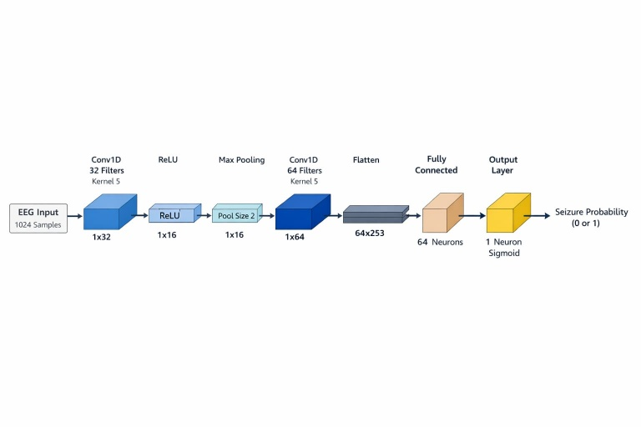
- CNN Workflow Architecture
The 1D-CNN architecture is designed to perform automated spatial feature extraction from raw EEG segments by learning a hierarchy of local temporal patterns through successive convolutional operations. The network architecture consists of three convolutional blocks, each comprising a one-dimensional convolutional layer, Batch Normalization, ReLU activation, and MaxPooling. The first convolutional block applies 64 filters of kernel size 3, capturing fine-grained local temporal patterns such as sharp transients and spike morphologies. The second block applies 128 filters of kernel size 3, learning higher-order combinations of the features extracted by the first block. The third block applies 256 filters of kernel size 3, encoding abstract, semantically rich representations of EEG signal structure across longer temporal extents.
Batch Normalization is applied after each convolutional layer to stabilize training dynamics, accelerate convergence, and reduce sensitivity to weight initialization. MaxPooling with a pool size of 2 follows each convolutional block, progressively reducing the temporal dimensionality of the feature maps while retaining the most salient activations. The convolutional output is subsequently flattened and passed through two fully connected layers of 256 and 128 units respectively, both employing ReLU activation and Dropout regularization with a rate of 0.5 to mitigate overfitting. The final output layer applies softmax activation over five units to produce the class probability distribution. The complete 1D-CNN model contains approximately 1.2 million trainable parameters and is trained using the Adam optimizer with a learning rate of 0.001 and categorical cross-entropy loss.

- Bidirectional Long Short-Term Memory (BiLSTM)
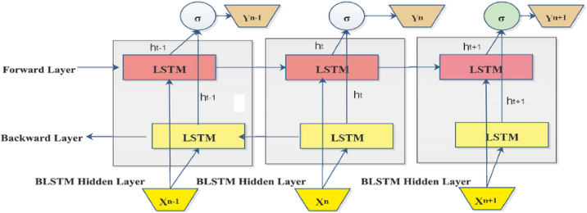
- Bidirectional LSTM Worflow Architecture

The BiLSTM architecture is designed to capture long-range sequential dependencies within EEG segments by processing the input time-series in both the forward and backward temporal directions simultaneously. Standard LSTM units address the vanishing gradient problem of vanilla RNNs through a gating mechanism comprising an input gate $i_{t}$, a forget gate $f_{t}$, an output gate $o_{t}$, and a cell state $C_{t}$, governed by the following recurrence relations:
$f_{t}​=σ(W_{f}​⋅[h_{t-1}, x_{t}]+b_{f}​)$
$$i_{t}=σ(W_{i}⋅[h_{t-1},x_{t}]+b_{i}) \\ {\tilde{C}}_{t}=tanh⁡(W_{C}⋅[h_{t-1},x_{t}]+b_{C}) \\ C_{t}=f_{t}⊙C_{t-1}+i_{t}⊙{\tilde{C}}_{t} \\ o_{t}=σ(W_{o}⋅[h_{t-1},x_{t}]+b_{o}) \\ h_{t}=o_{t}⊙tanh⁡(C_{t})$$
The bidirectional extension augments each LSTM layer with a reverse-direction LSTM that processes the input sequence from the final timestep to the first, producing a backward hidden state ${\overset{⃖}{h}}_{t}$. The forward and backward hidden states are concatenated at each timestep, yielding a combined representation $\left[{\vec{h}}_{t} ; {\overset{⃖}{h}}_{t}\right]$that encodes both past and future temporal context, a property of particular value in EEG analysis, where the onset and cessation of ictal activity are defined by bidirectional contextual patterns.
The BiLSTM network comprises two stacked bidirectional LSTM layers with 128 units each (yielding 256-dimensional concatenated outputs), followed by Dropout regularization with a rate of 0.5 between layers. The recurrent output is passed through two fully connected layers of 128 and 64 units with ReLU activation before the final softmax classification layer. The model is trained using the Adam optimizer with a learning rate of 0.001 and categorical cross-entropy loss.

- CNN-LSTM Hybrid Architecture
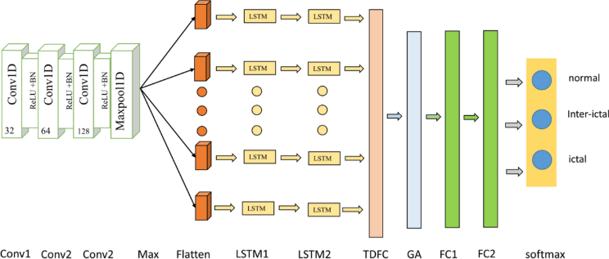
- CNN-BiLSTM Workflow Architecture
The CNN-LSTM Hybrid model is designed to synergistically integrate the spatial feature extraction capabilities of convolutional layers with the sequential temporal modeling capabilities of LSTM units, addressing the complementary limitations of each architecture in isolation. The motivation for this fusion is grounded in the observation that raw EEG segments contain both local morphological features which are transient spike discharges, sharp waves, best captured by convolutional operations, and long-range temporal dynamics, rhythmic oscillations, seizure onset and propagation patterns are best modeled by recurrent units.
The hybrid architecture proceeds in two sequential stages. In the first stage, two one-dimensional convolutional blocks, each comprising a Conv1D layer (64 and 128 filters respectively, kernel size 3), Batch Normalization, ReLU activation, and MaxPooling, they extract a compact sequence of high-level spatial feature maps from the raw input segment. These feature maps, of reduced temporal dimensionality, serve as the sequential input to the second stage. In the second stage, a Bidirectional LSTM layer with 128 units receives the convolutional feature sequence, modeling the temporal evolution and interdependencies of the extracted spatial features across the segment. This two-stage design enables the model to learn what features are present at each local temporal position via convolution, and how those features relate and evolve over time via recurrent processing.
The LSTM output is followed by a fully connected layer of 128 units with ReLU activation and Dropout (rate 0.5), before the final softmax output layer. The hybrid model is trained with the Adam optimizer at a learning rate of 0.001. As reported in the experimental results, the CNN-LSTM Hybrid achieves a classification accuracy of 93.1% and an F1-score of 93.1%, confirming that the integration of spatial and temporal learning yields competitive performance, though the pure 1D-CNN marginally outperforms the hybrid on this particular dataset configuration, potentially attributable to the relatively short 512-sample segment length which may limit the sequential context available to the LSTM component.

WORKFLOW
- Pipeline
The system workflow consists of sequential stages beginning with raw EEG input and ending with classification output:
Raw EEG Signal → Preprocessing → Feature Extraction / Automated Learning → Model Training → Evaluation → Deployment
Raw EEG recordings from the Bonn University dataset (Sets A–E), each containing 4096 samples, are ingested from plain text files and labeled according to their respective classes. Each recording is segmented into 512-sample windows and normalized using Z-score normalization, improving data consistency and model convergence.
Two parallel processing paths are then employed. For classical machine learning models, handcrafted features are extracted using Power Spectral Density (PSD) via Welch’s method and Discrete Wavelet Transform (DWT) with the db4 wavelet. For deep learning models, the normalized EEG segments are provided directly as input, enabling automatic feature extraction.
The system trains six classifiers within a unified framework: Random Forest, SVM, Decision Tree, 1D-CNN, BiLSTM, and a CNN–LSTM hybrid model. All models are evaluated using accuracy, precision, recall, F1-score, and confusion matrices on a held-out test set.

- Training Configuration
All deep learning models are trained using a consistent configuration to ensure fair comparison and stable convergence. The Adam optimizer is employed with an initial learning rate of 0.001 and categorical cross-entropy loss. A batch size of 32 and a maximum of 100 epochs are used, with 20% of the training data reserved for validation.
To prevent overfitting, two training callbacks are applied:
- ReduceLROnPlateau, which reduces the learning rate by a factor of 0.5 when validation loss stagnates for 10 epochs.
- EarlyStopping, which halts training if no validation improvement is observed for 20 epochs and restores the best-performing model weights.
Additionally, Dropout regularization (rate = 0.5) is applied in the fully connected layers to improve generalization.

- Deploeyment Architecture
The trained deep learning models are serialized and integrated into a Web application for real-time inference. The application accepts raw EEG files, performs preprocessing internally, and outputs the predicted EEG class along with a confidence score and seizure indication. Segment-level predictions are aggregated using majority voting to improve robustness against noise and artifacts.

Results
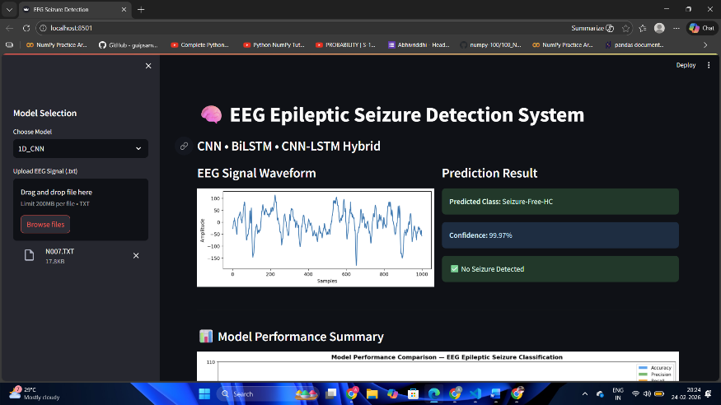
- Output on website classifying into current class

- Performance Evaluation
Traditional machine learning models show reasonable performance when trained on handcrafted PSD and DWT features; however, they are consistently outperformed by deep learning approaches. This demonstrates the advantage of automated feature learning for complex, non-stationary EEG signals.

Model | Accuracy (%) | Precision (%) | Recall (%) | F1-Score (%)
Random Forest | 84.6 | 84.9 | 84.6 | 84.5
SVM | 86.2 | 86.5 | 86.2 | 86.1
1D-CNN | 90.8 | 91.0 | 90.8 | 90.8
BiLSTM | 91.9 | 92.1 | 91.9 | 91.9
CNN–LSTM Hybrid | 93.1 | 93.3 | 93.1 | 93.1
Table.2. Performance Evaluation Table of 5 trained models

- Confusion Matrix and Training Analysis
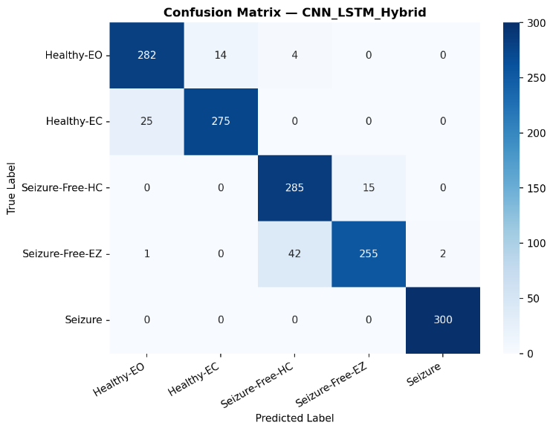
- Confusion Matrix CNN-LSTM-Hybrid
The confusion matrices illustrate that classical models exhibit higher misclassification rates between seizure-free and healthy EEG classes. In contrast, deep learning models show improved class separation, with the CNN–LSTM hybrid model achieving the most balanced classification across all five EEG classes.
Training history plots further confirm these findings. The 1D-CNN converges rapidly but exhibits minor fluctuations in validation loss, indicating limited temporal modeling capability. The BiLSTM shows smoother convergence due to its ability to model long-term dependencies. The CNN–LSTM hybrid demonstrates both fast convergence and stable validation performance, indicating superior generalization and reduced overfitting.
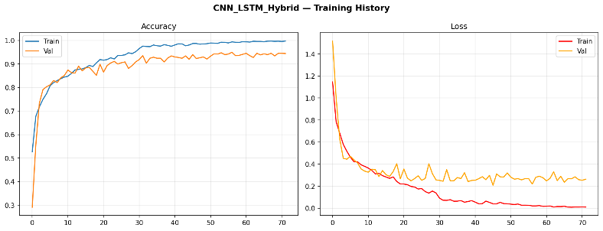
- CNN-LSTM-Hybrid Training Accuracy and Loss

- Success Analysis of the Hybrid Model

The superior performance of the CNN–LSTM hybrid architecture can be attributed to its ability to jointly model spatial and temporal characteristics of EEG signals. The CNN component effectively reduces noise and dimensionality by extracting localized discriminative features from raw EEG segments. These compact feature representations are then passed to the LSTM layers, which capture long-term temporal dependencies and sequential patterns inherent in epileptic activity.
This division of responsibilities allows the hybrid model to overcome the individual limitations of standalone CNN and LSTM architectures. As a result, the CNN–LSTM hybrid achieves the highest accuracy and F1-score, making it the most effective model for multi-class epileptic seizure detection within the proposed framework.

SUCCESS AND FAILURE ANALYSIS
- Success Analysis
The experimental results clearly demonstrate the effectiveness of deep learning–based approaches for multi-class EEG classification. Among all evaluated models, the CNN–LSTM hybrid architecture achieved the highest accuracy and F1-score, indicating superior generalization across all five EEG classes. This success is primarily due to the complementary strengths of the hybrid design: the CNN layers efficiently suppress noise and reduce signal dimensionality by learning localized discriminative features, while the LSTM layers capture long-term temporal dependencies inherent in EEG signals. This spatial–temporal fusion enables more robust discrimination between seizure, seizure-free, and healthy EEG states compared to standalone CNN or BiLSTM models.

- Failure Analysis
Despite strong overall performance, certain misclassifications persist, most notably between Healthy–Eyes Open (Set A) and Healthy–Eyes Closed (Set B) signals. These errors arise from the high similarity in neurophysiological patterns between the two classes, with only subtle differences in alpha-band activity. Minor confusion is also observed between seizure-free classes (Sets C and D), reflecting the inherent variability and low-amplitude nature of interictal EEG signals. Additionally, while traditional classifiers offer faster inference, they exhibit reduced accuracy due to their reliance on handcrafted features, highlighting a trade-off between computational efficiency and classification performance.

CONCLUSION
This study presented a comprehensive EEG-based epileptic seizure classification framework combining traditional machine learning techniques with advanced deep learning models. A five-class classification problem was addressed using the Bonn University EEG dataset, enabling discrimination between healthy, seizure-free, and seizure states. Experimental results demonstrated that deep learning approaches consistently outperform traditional classifiers, with the CNN–LSTM hybrid model achieving the best overall performance in terms of accuracy, precision, recall, and F1-score. The superior results of the hybrid architecture highlight the effectiveness of integrating convolutional feature extraction with recurrent temporal modeling for complex EEG signal analysis.
Despite its strong performance, the proposed framework can be further enhanced in future work. Evaluation on larger and more diverse EEG datasets, such as the CHB-MIT scalp EEG database, would improve generalization and clinical applicability. Additionally, deploying the trained models on real-time hardware platforms, including FPGA-based accelerators or Edge AI devices, could enable low-latency seizure detection for continuous patient monitoring. Future research may also explore patient-specific adaptation and lightweight model compression techniques to further optimize performance for real-world clinical deployment.

Acknowledgment
The authors would like to express their gratitude to Vishwakarma Institute of Technology, Pune, for providing the resources and environment necessary for this research. The authors also sincerely thank Prof. Amruta Mankawade for her guidance and support, as well as Prof. Shital Dongre, Head of the Department of Artificial Intelligence and Data Science.

References

- World Health Organization, "Epilepsy: Key facts," WHO, Geneva, Switzerland, Feb. 2023.
- R. G. Andrzejak, K. Lehnertz, F. Mormann, C. Rieke, P. David, and C. E. Elger, "Indications of nonlinear deterministic and finite-dimensional structures in time series of brain electrical activity: Dependence on recording region and brain state," Physical Review E, vol. 64, no. 6, p. 061907, Nov. 2001.
- A. Subasi, "EEG signal classification using wavelet feature extraction and a mixture of expert model," Expert Systems with Applications, vol. 32, no. 4, pp. 1084–1093, May 2007.
- E. D. Übeyli, "Analysis of EEG signals by combining eigenvector methods and multiclass support vector machines," Computers in Biology and Medicine, vol. 38, no. 1, pp. 14–22, Jan. 2008.
- A. H. Shoeb and J. V. Guttag, "Application of machine learning to epileptic seizure detection," in Proc. 27th Int. Conf. Machine Learning (ICML), Haifa, Israel, Jun. 2010, pp. 975–982.
- U. R. Acharya, S. V. Sree, G. Swapna, R. J. Martis, and J. S. Suri, "Automated EEG analysis of epilepsy: A review," Knowledge-Based Systems, vol. 45, pp. 147–165, Jun. 2013.
- U. R. Acharya, S. L. Oh, Y. Hagiwara, J. H. Tan, and H. Adeli, "Deep convolutional neural network for the automated detection and diagnosis of seizure using EEG signals," Computers in Biology and Medicine, vol. 100, pp. 270–278, Sep. 2018.
- Q. Yuan, W. Zhou, S. Li, and D. Cai, "Epileptic EEG classification based on extreme learning machine and nonlinear features," Epilepsy Research, vol. 96, no. 1–2, pp. 29–38, Sep. 2011.
- K. M. Tsiouris, V. C. Pezoulas, M. Zervakis, S. Konitsiotis, D. D. Koutsouris, and D. I. Fotiadis, "A long short-term memory deep learning network for the prediction of epileptic seizures using EEG signals," Computers in Biology and Medicine, vol. 99, pp. 24–37, Aug. 2018.
- T. N. Sainath, O. Vinyals, A. Senior, and H. Sak, "Convolutional, long short-term memory, fully connected deep neural networks," in Proc. IEEE Int. Conf. Acoustics, Speech and Signal Processing (ICASSP), South Brisbane, QLD, Australia, Apr. 2015, pp. 4580–4584.
- D. Zhang, L. Yang, X. Yuan, and J. Huang, "Epileptic seizure detection using convolutional neural network with transfer learning," in Proc. IEEE Int. Conf. Bioinformatics and Biomedicine (BIBM), Madrid, Spain, Dec. 2018, pp. 1040–1044.

